**VALUE PROPOSITION WORKSHEET**

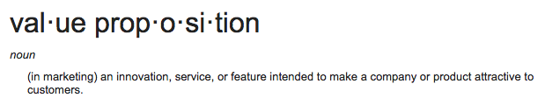**Value Proposition: MUST HAVES**

***As a business, your job is to foster a conclusion of value.***

You therefore must provide simplified explanations that are aimed at teaching and serving the attentive listener. You need to explain and help the listener believe.

The goal is to help them build the right conclusions. (Your service/product is the no-brainer choice, of course)

**Complete These Thoughts:**

* [Our Service/Product] value proposition is:
* A prospect should buy from us rather than our competitors because…

**Breaking the Value Proposition Down:**

“It” Must Pass the 4-Conclusion Test

1. **I want it.   
   (what exactly is the “it” your prospect wants?)**
2. **Can’t get it like this anywhere else.  
   (explain what’s exclusive and how you execute “it” unlike anywhere else.)**
3. **I understand it. (instantly)  
   (what can you point to that de-mystifies, uncomplicates your explanation?)**
4. **I believe it.  
   (not just me saying… it’s naturally believable because?)**