**80–15–5 APPROACH**

**Planning Tool: The 80-15-5 Approach**

***The concept is easy. The execution? Well… that’s always the key.***

Here’s a planning tool that can simplify your planning.

**These are the rules to follow:**

**of your budget goes toward consistent performers that keep your brand moving toward your mission-based outcome.**

**80%** I

**of your budget goes toward up-and-coming platforms, assets, tools etc. that have shown promise, but aren’t yet “consistent” performers.**

**15%** I

**of your budget goes toward the hunches, the researched opportunities, the things you want to try but can’t justify making significant allocations… yet.**

**5%** I

*Your mix might include channels like these, in example:*

|  |  |  |
| --- | --- | --- |
| **80%** | **15%** | **5%** |
| Marketing Automation (subscription)  Paid search  Facebook paid ads  Twitter paid ads  SEO (agency/app)  LinkedIn paid media  Display ads | Conversion rate optimization tool  Facebook boosted posts  Native ads | Periscope Live Video  Streaming Advertising |

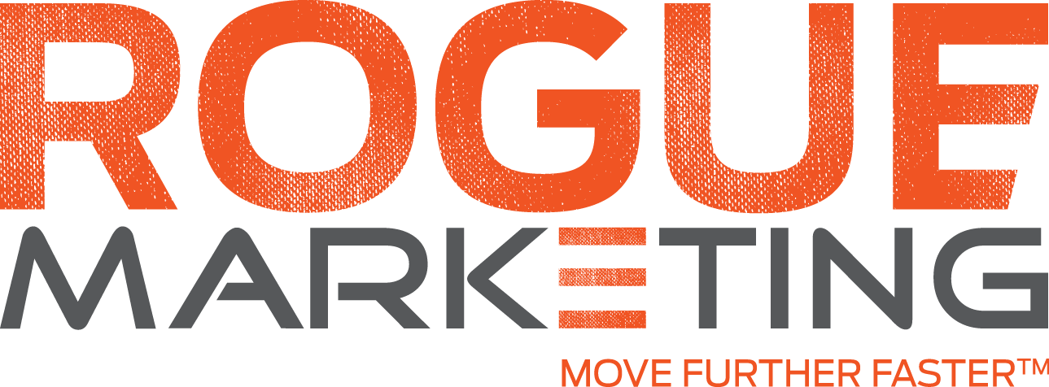****

**Your turn:**

|  |  |  |  |  |  |  |  |  |  |  |  |  |  |  |
| --- | --- | --- | --- | --- | --- | --- | --- | --- | --- | --- | --- | --- | --- | --- |
|  | Channel | Jan | Feb | Mar | Apr | May | June | July | Aug | Sept | Oct | Nov | Dec | Total |
| 80%  or  $12,800 | Platform 1 | $6,500.00 | $6,500.00 | $6,500.00 | $6,500.00 | $6,500.00 | $6,500.00 | $6,500.00 | $6,500.00 | $6,500.00 | $6,500.00 | $6,500.00 | $6,500.00 | $78,000.00 | |
| Platform 2 | $3,000.00 | $3,000.00 | $3,000.00 | $3,000.00 | $3,000.00 | $3,000.00 | $3,000.00 | $3,000.00 | $3,000.00 | $3,000.00 | $3,000.00 | $3,000.00 | $36,000.00 | |
| Platform 3 | $3,300.00 | $3,300.00 | $3,300.00 | $3,300.00 | $3,300.00 | $3,300.00 | $3,300.00 | $3,300.00 | $3,300.00 | $3,300.00 | $3,300.00 | $3,300.00 | $39,600.00 | |
| 15%  or $2,400 | Platform 1 | $1,500.00 | $1,500.00 | $1,500.00 | $1,500.00 | $1,500.00 | $1,500.00 | $1,500.00 | $1,500.00 | $1,500.00 | $1,500.00 | $1,500.00 | $1,500.00 | $18,000.00 | |
| Platform 2 | $900.00 | $900.00 | $900.00 | $900.00 | $900.00 | $900.00 | $900.00 | $900.00 | $900.00 | $900.00 | $900.00 | $900.00 | $10,800.00 | |
| Platform 3 | $- | $- | $- | $- | $- | $- | $- | $- | $- | $- | $- | $- | $- | |
| 5%  or  $800 | Platform 1 | $500.00 | $500.00 | $500.00 | $500.00 | $500.00 | $500.00 | $500.00 | $500.00 | $500.00 | $500.00 | $500.00 | $500.00 | $6,000.00 | |
| Platform 2 | $300.00 | $300.00 | $300.00 | $300.00 | $300.00 | $300.00 | $300.00 | $300.00 | $300.00 | $300.00 | $300.00 | $300.00 | $3,600.00 | |
| Platform 3 | $- | $- | $- | $- | $- | $- | $- | $- | $- | $- | $- | $- | $- | |
| Media Management Fee (20%) | | $4,000.00 | $4,000.00 | $4,000.00 | $4,000.00 | $4,000.00 | $4,000.00 | $4,000.00 | $4,000.00 | $4,000.00 | $4,000.00 | $4,000.00 | $4,000.00 | $48,000.00 | |
| Monthly Media Investment Amount | | $20,000.00 | $20,000.00 | $20,000.00 | $20,000.00 | $20,000.00 | $20,000.00 | $20,000.00 | $20,000.00 | $20,000.00 | $20,000.00 | $20,000.00 | $20,000.00 | $240,000.00 | |

Call: 214.932.9159

Email: Hello@GoRogue.net

Go**Rogue**.net

Call: 214.932.9159

Email: Hello@GoRogue.net

Go**Rogue**.net

Call: 214.932.9159

Email: Hello@GoRogue.net