**CTV OR CALL TO ACTION?**

**Tool: Do You Need a CTV or CTA?**

***On the path to conversion, awareness is the first step.***

Do you know what type of action a prospect will want to take at each step of the

5 Stages of Awareness and how to speed up their movement to the next?

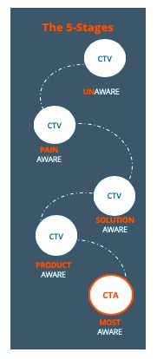(Many marketers jump too quickly to CTA.)

**When to Use Which?**

**Call to Action**

**This is used to call an audience to a focused action: download a free ebook, request a demo, save your seat. Until your prospect is at the MOST AWARE stage, you’re not ready to call them to any action… you need to call them to a next stage of value.**

**Call to Value**

**A CTV completes the phrase, “I want to _____.” You are giving a promise of the value an action someone takes will hold… rather than focusing on the action itself.**

**CALL TO ACTION or CALL TO VALUE**

DOWNLOAD

FREE EBOOK

CREATE CONTENT STRATEGY IN 10 MINUTES

**The best CTAs and CTVs will use the actual words of your customers when they’re looking for solutions at their different stages of awareness. That’s why you need to collect the voice of your customer through interviews.**